TOGAF® Standard – Architecture Deliverables Phase C
Version 1.0
October 2026
Barangay San Antonio Health Department Enterprise Architecture
Barangay San Antonio Health Center, Pasig City
Document Version History
Version  Number | Version  Date | Revised By | Description | Filename
1.0 | October 22, 2026 | UA&P Solution Architecture team | First issue, based on interviews (October 2–21, 2026) and verification answers (October 22, 2026) | C1 - Architecture Deliverables (Phase C).docx

Contents
1. Architectural Artifacts 4
2. Phase C: Data Architecture Artifacts 7
2.1 Data Entity/Data Component Catalog 7
2.2 Logical Data Diagram 8
2.3 Data Entity/Business Function Matrix 8
2.4 Data Security Diagram 9
2.5 Data Dissemination Diagram 9
2.6 Data Lifecycle Diagram 10
2.7 Data Gap Analysis 10
3. Phase C: Application Architecture Artifacts 12
3.1 Application Portfolio Catalog 12
3.2 Interface Catalog 12
3.3 Role/Application Matrix 12
3.4 Application/Function Matrix 13
3.5 Application Communication Diagram 13
3.6 Application Gap Analysis 14
A Abbreviations 15
Tracking Information
Project Name | Barangay San Antonio Health Department Enterprise Architecture
Prepared By | Rome Victor Mag-iba Sendin (Group Leader); Samuel Anthonius Badillo; Wilson Halim; Kevin Enrico Ang | Document Version No. | 1.0
Title | Architecture Deliverables – Phase C: Information Systems Architecture | Document Version Date | October 22, 2026
Reviewed By | Dr. Glynnis Lynn U. Bonilla, Medical Officer IV (Executive Sponsor) | Review Date | October 23, 2026
Distribution List
From | Date | Phone/Email
Rome Victor Mag-iba Sendin, Group Leader, UA&P Solution Architecture | October 22, 2026 | romevictor.sendin@uap.asia / 09456315746

To | Action* | Due Date | Phone//Email
Dr. Glynnis Lynn U. Bonilla, Medical Officer IV | Approve | October 23, 2026 | bsahealthcenter@gmail.com
Hon. Thomas Raymond U. Lising, Punong Barangay | Review | October 23, 2026 | bsahealthcenter@gmail.com
Hon. Rachel Marie S. Rustia-Olarte, Co-Chair, Committee on Health & Nutrition | Review | October 23, 2026 | bsahealthcenter@gmail.com
Mr. Joel Pira, Instructor, Solution Architecture (UA&P) | Review | October 23, 2026 | joel.pira@uap.asia
* Action Types: Approve, Review, Inform, File, Action Required, Attend Meeting, Other (please specify)

Architectural Artifacts
While the Enterprise Metamodel is used to support the structuring of architectural information, most stakeholders do not need or wish to know the detail contained within the Architecture Content Framework in this manner. Therefore, the use of catalogs, matrices, and diagrams is introduced to facilitate the presentation of architectural information so that it may be used for reference and governance purposes more readily.
Catalogs are lists of building blocks of a specific type or related types, matrices are grids that show relationships between two or more entities, and diagrams are graphical renderings of architectural content.
In summary, the result of an Architecture Development Method (ADM) developed architecture consists of a number of defined Architecture Building Blocks populated into architecture catalogs, with relationships specified between those building blocks in architecture matrices, and/or also presented as diagrams, as appropriate to satisfy the stakeholder concerns.
The TOGAF® Standard provides a set of recommended artifacts, summarized as follows:
ADM Phase | Artifact
Preliminary Phase | Principles catalog
Phase A | Stakeholder Map matrix  Value Chain diagram  Solution Concept diagram  Business Model diagram  Business Capability map  Value Stream map
Phase B | Organization/Actor catalog  Driver/Goal/Objective catalog  Role catalog  Business Service/Function catalog  Location catalog  Process/Event/Control/Product catalog  Contract/Measure catalog  Business Capabilities catalog  Value Stream catalog  Value Stream Stages catalog  Business Interaction matrix  Actor/Role matrix  Value Stream/Capability matrix  Strategy/Capability matrix  Capability/Organization matrix  Business Footprint diagram  Business Service/Information diagram  Functional Decomposition diagram  Product Lifecycle diagram  Goal/Objective/Service diagram  Business Use-Case diagram  Organization Decomposition diagram  Process Flow diagram  Event diagram  Business Capability map (updated)  Value Stream map (updated)  Organization map
Phase C: Data Architecture | Data Entity/Data Component catalog  Data Entity/Business Function matrix  Application/Data matrix  Conceptual Data Diagram  Logical Data Diagram  Data Dissemination diagram  Data Security diagram  Data Migration diagram  Data Lifecycle diagram
Phase C: Application Architecture | Application Portfolio catalog  Interface catalog  Application/Organization matrix  Role/Application matrix  Application/Function matrix  Application Interaction matrix  Application Communication diagram  Application and User Location diagram  Application Use-Case diagram  Enterprise Manageability diagram  Process/Application Realization diagram  Software Engineering diagram  Application Migration diagram  Software Distribution diagram
Phase D | Technology Standards catalog  Technology Portfolio catalog  Application/Technology matrix  Environments and Locations diagram  Platform Decomposition diagram  Processing diagram  Networked Computing/Hardware diagram  Network and Communications diagram
Phase E | Project Context diagram  Benefits diagram
Requirements Management | Requirements catalog

Phase C: Data Architecture Artifacts

Data Entity/Data Component Catalog
Entity | Key attributes | Where held today | Owner | Sensitivity / retention
Patient (ITR) | Record no., name, address, contact, birthdate, sex, civil status, PhilHealth no. and category, family/guardian, COVID doses | Paper ITR; City EMR | Encoder / nurse | Personal; 7 years
Consultation Encounter (Patient Chart) | Date, weight, height, BP, PR, RR, temp, O2 sat, LMP, sugar, complaint, history, exam, impression, plan, prescription, doctor, follow-up | Paper chart; City EMR | Doctor | Health; 7 years
Consent Record | Services checked, signature, authorized person, relationship, date/time | On ITR and every chart entry | Nurse | Legal; 7 years
Prescription | Medicine, dose, quantity, prescriber | Chart; EMR; YAKAP; dental eMED | Doctor / dentist | Health
GAMOT / YAKAP Entry | Beneficiary, address, date, UPSC, age, sex, medicines and quantity, follow-up date, QR code | PhilHealth portal; GAMOT logbook | Doctor / encoder | Health
Immunization Record | Vaccine, dose, date, brand | Chart; vaccine card; EMR | Nurse / midwife | Health
Maternal / Family Planning Record | Pregnancy, deliveries, FP method, unmet need | Chart; EMR; aides' tallies | Midwife | Sensitive
TB Case Record | Case, sputum / GeneXpert results, treatment | GeneXpert, sputum and TB logbooks; DOH ITIS | Nurse | Sensitive
Mental Health Record | Case, medication | Mental health logbook; locked | Nurse, midwife, doctor only | Highly sensitive
NCD / Maintenance Monitoring | Patient, medicine, quantity, date, BP | NCD form; monthly monitoring sheet | Nurse / aides | Health
Dental Record | Dental chart, vitals, treatment | Paper dental record; dental eMED | Dentist | Health
OPT Measurement | Child 0–59 months: name, birthdate, sex, weight, height, vitamin A, deworming | e-OPT form; NNC e-OPT tool; Google Sheets | BNS / nutritionist | Personal (children)
Referral | Patient, destination, reason, escort | Referral slip (no log) | Doctor / nurse | Health
Medicine Stock Transaction | Item, beginning balance, received, issued, ending balance | Manual utilization sheets; requisition and delivery slips; LMIS receipts | Nurse | Operational
Monthly Program Report | Program, period, tallies | Excel / Google Drive (personal); signed hard copies | Program owners | Aggregate
Ovitrap / Larvatrap Record | Household, result, date | Paper; 2-weekly report | Aides / BHWs | Aggregate
Equipment and Borrower Log | Item, borrower, date | Borrowers' and equipment logbooks | Custodian (Ms. Roa) | Operational
Visitor Log; Staff Attendance / DTR | Name, purpose, time | Logbooks; DTR | Security; each staff | Personal
Record Disposal Entry | Record type, location, disposal date, collector | Records storage/retention/disposal logbook | Custodian | Audit

Logical Data Diagram
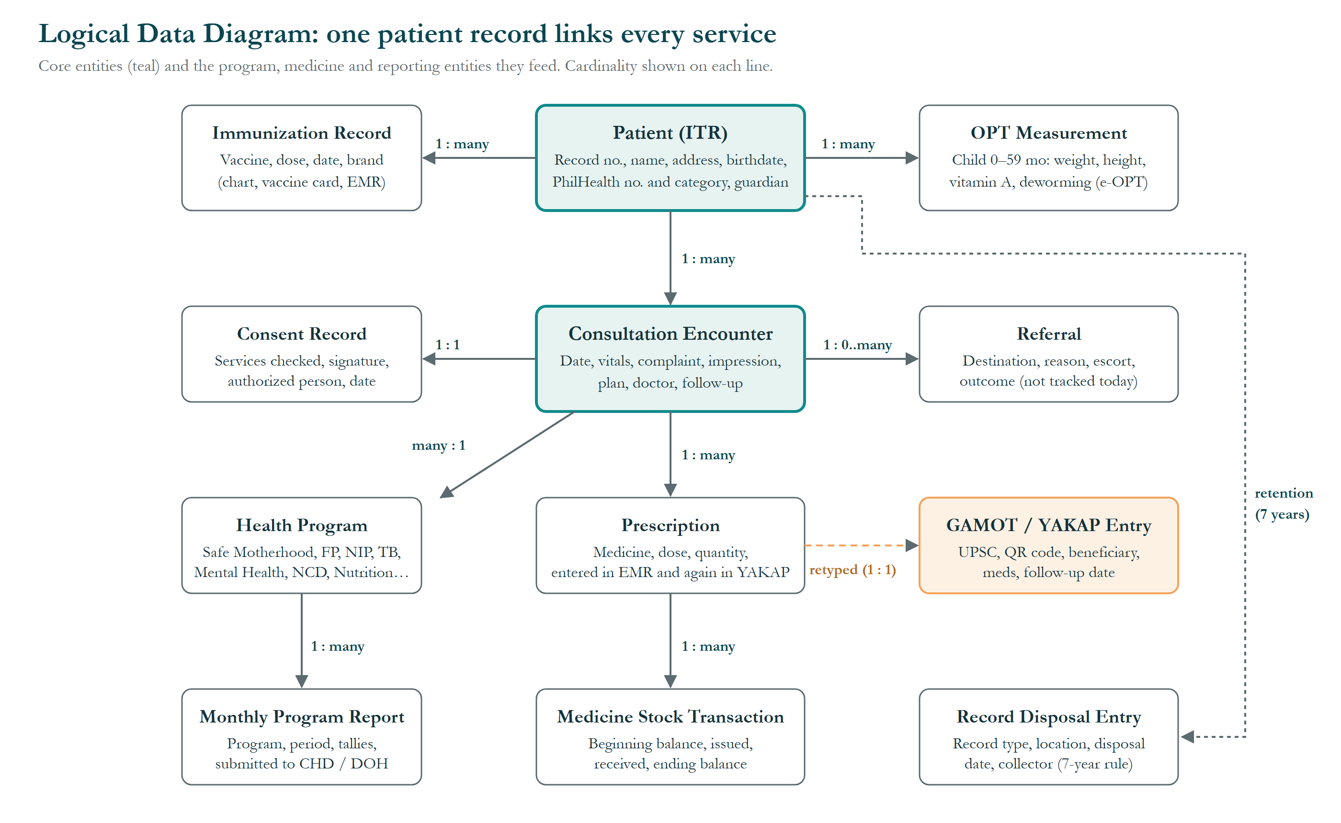
Figure 1. Logical Data Diagram.
How to read it: each box is a data entity with its key attributes; teal boxes are the core patient entities. Labels on the lines give the relationship: “1 : many” means one patient has many consultations; “1 : 0..many” means a patient may have none or several; “retyped (1 : 1)” marks the same data entered twice.
- Patient (ITR) is the hub. Its record number ties the paper chart to the EMR, applying “One Patient, One Record”.
- Prescription → GAMOT/YAKAP entry is the main duplication: the same medicines entered twice.
- Medicine Stock Transaction connects dispensing to stock but lives on hand-written sheets.
- Referral outcome is not tracked today.
- Record Disposal Entry applies the DOH 7-year retention rule.
- Full attributes, owners and sensitivity are in the Data Entity/Data Component Catalog (Section 2.1).

Data Entity/Business Function Matrix
C = Create · R = Read · U = Update · D = Delete/dispose.
Entity | Registration | Consultation | Dispensing | Medicine logistics | Outreach | Reporting | Records custody
Patient (ITR) | C, U | R | R |  | R | R | D
Consultation Encounter | C (vitals) | C, U | R |  |  | R | D
Consent Record | C | C |  |  |  |  | D
Prescription |  | C | R | R |  | R
GAMOT / YAKAP Entry |  | C | R |  |  | R
Immunization Record |  | C |  |  | C | R | D
OPT Measurement |  |  |  |  | C, U | R
Referral |  | C |  |  |  | R
Medicine Stock Transaction |  |  | C | C, U |  | R
Monthly Program Report |  |  |  |  |  | C, U
Record Disposal Entry |  |  |  |  |  |  | C

Data Security Diagram
Entity | Who can access | Protection today | Gap
Paper patient records | All health center staff | Records room: only the main door is locked; custodian holds the key | No internal lock or key log
Mental health records | Nurse, midwife, doctor | Kept separate | Not documented as a rule
Nurse's program records | On request | Verbal permission; photocopy or photo given | No written access log
City EMR | Encoder, doctor, midwife, dentist (own accounts) | Individual accounts | Cross-barangay visibility unconfirmed (to ask Mr. Reyes)
Program files and chats | Owner of personal account | Personal passwords only | Work data on personal accounts
Consent | — | Signed on ITR and at every visit | Repeated per visit

Data Dissemination Diagram
Data | Sent to | How | Frequency
Program reports (NIP, TB, mental health, FP, maternal, NCD, medicines) | CHD program coordinators | Google Drive, then printed signed copies hand-carried | Monthly, quarterly, annual
Morbidity and service statistics | CHD Medstat; DOH FHSIS | EMR export | Monthly
Vaccine and mental-health medicine inventory | DOH | Inventory report | Monthly
TB cases | DOH | ITIS | Ongoing
OPT results | City Nutrition Office → region → national | NNC e-OPT | Jan–Mar
Nutrition reports (M1, BNS monthly, bi-annual) | City Nutrition Office | Google Drive | Monthly; June and December
Ovitrap results | Dengue Task Force office | Paper | Every 2 weeks
YAKAP prescriptions and claims | PhilHealth; YAKAP pharmacy | Portal; QR code | Per patient
Equipment inventory | DOH, LGU, barangay | Custodian report | Monthly
Barangay health spending | City Accounting Office | Treasurer's report | Periodic

Data Lifecycle Diagram
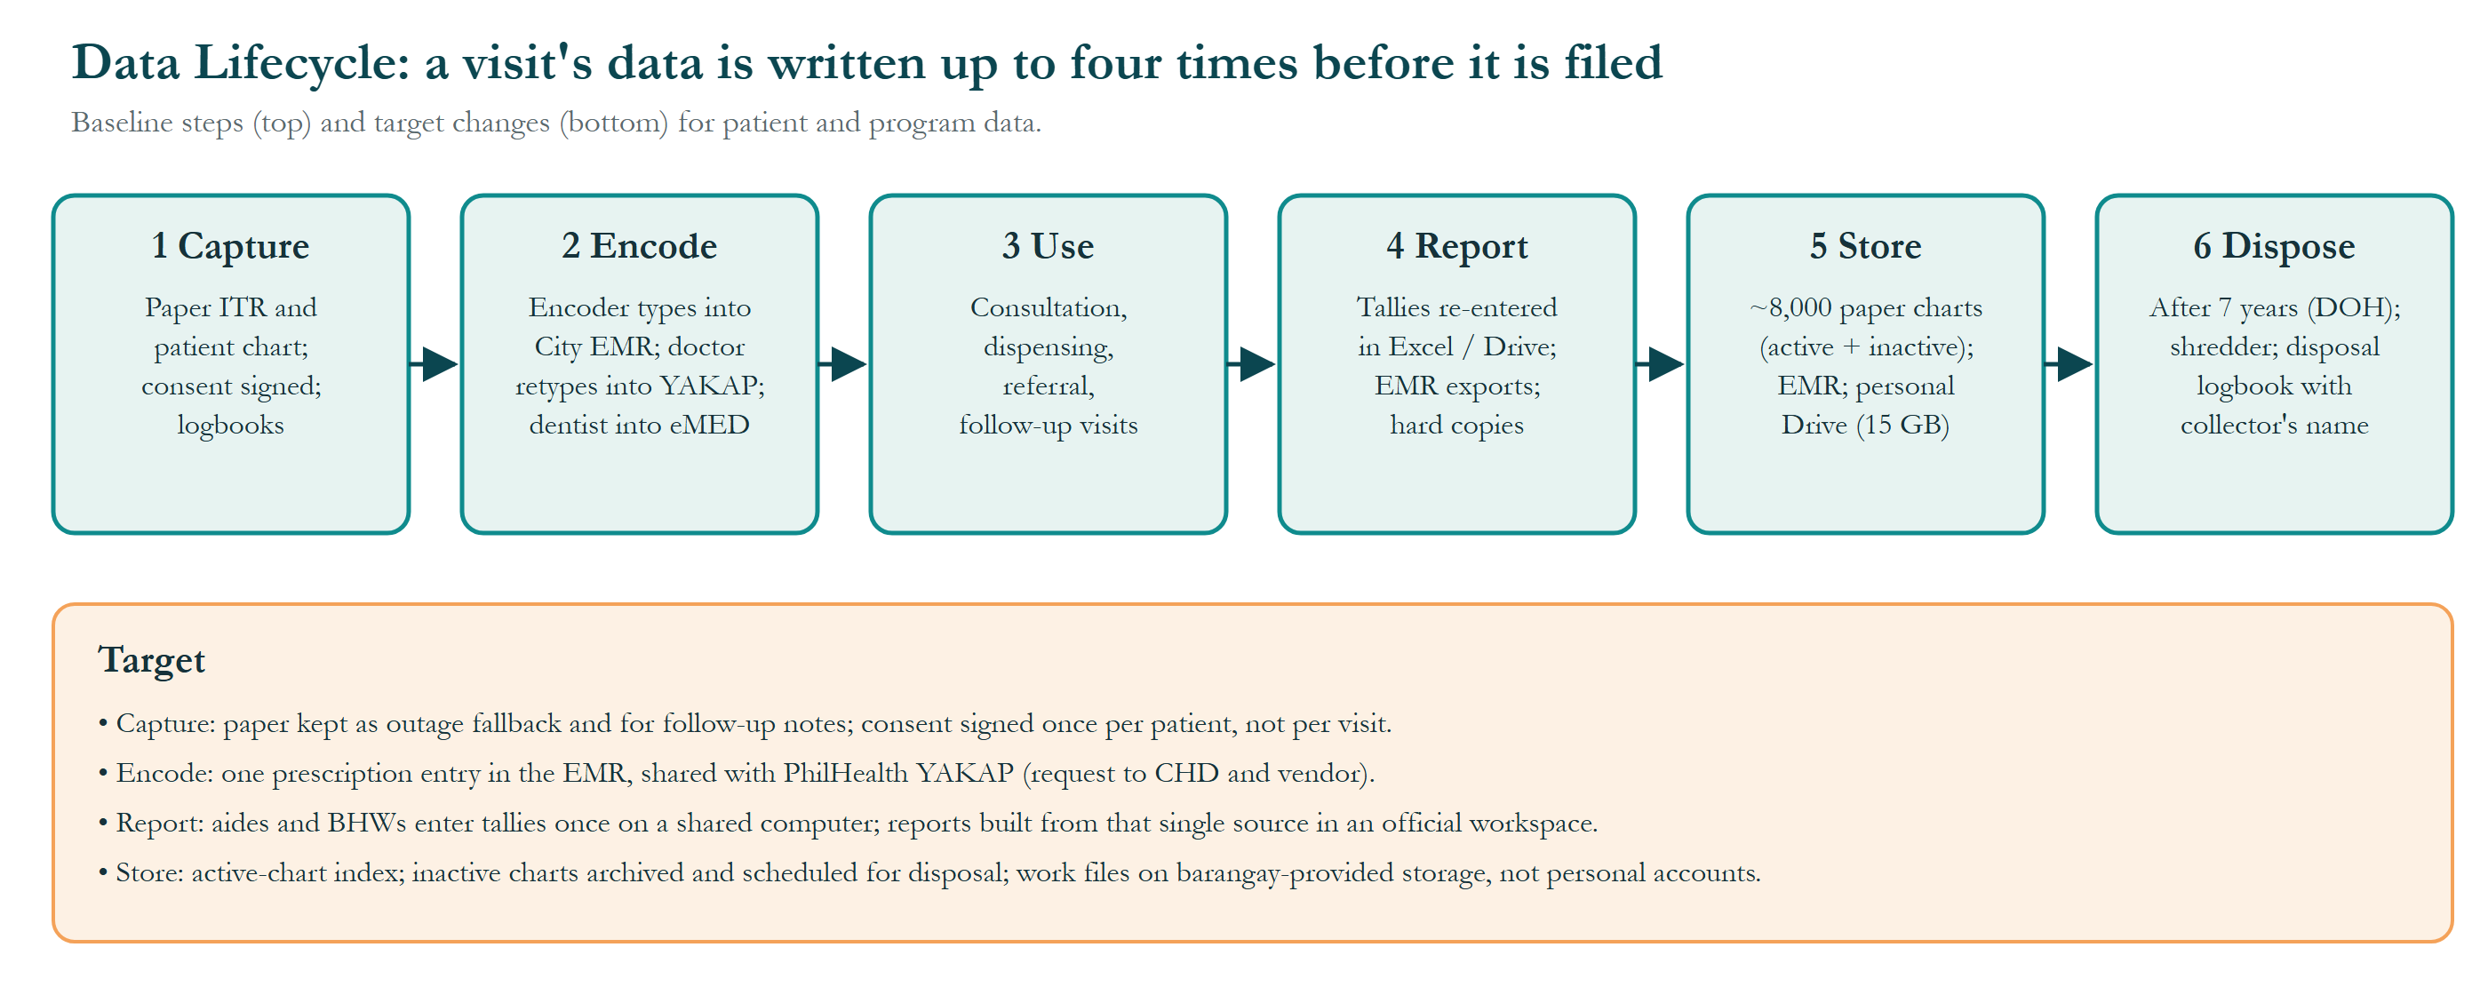
Figure 2. Data Lifecycle.
How to read it: the six numbered boxes are the stages a visit's data passes through, left to right; the “Target” panel below gives the planned change per stage.
- Encode (stage 2) and Report (stage 4) are where data is re-entered: encoder into the EMR, doctor into YAKAP, dentist into eMED, tallies into Excel/Drive.
- Store (stage 5): about 8,000 paper charts (active and inactive mixed) and personal 15 GB Drive accounts.
- Dispose (stage 6) is already well controlled: DOH 7-year rule, shredder, and a disposal logbook with the collector's name.
- Targets: consent once per patient (CHD approval); one prescription entry (City request); single tally source in an official workspace; active-chart index with inactive charts archived.

Data Gap Analysis
ID | Gap | Target | Controlled by
DG-1 | Prescription data entered up to three times (chart, EMR, YAKAP / dental eMED) | Single entry shared across systems | City / vendor
DG-2 | About 8,000 charts with active and inactive records mixed | Active-chart index; inactive charts archived on the 7-year schedule | Health center
DG-3 | Program tallies captured on paper, then retyped | Tallies entered once on a shared computer | Health center / Barangay
DG-4 | Work files on personal Google accounts (15 GB; nutritionist pays ₱200–400 a month) | Barangay-owned workspace and storage | Barangay
DG-5 | Medicine stock tracked by hand | Digital stock record with reorder levels | Health center
DG-6 | No referral log or outcome tracking (~30 referrals a month) | Referral register with outcomes | Health center
DG-7 | Access to program records granted by verbal permission; records room locked only at the main door | Written access rule and key log; lockable cabinet | Health center
DG-8 | Consent signed at every visit | Consent once per patient, renewed when services change | Health center (CHD approval)

Phase C: Application Architecture Artifacts

Application Portfolio Catalog
Application | Owner | Purpose | Users | Issues
City EMR (eMed) | City of Pasig; outsourced vendor (~2023) | Registration, vitals, diagnosis, prescriptions, report generation | Encoder, doctor, midwife, dentist | Slow at peak; internet-dependent; vendor-only changes
Dental eMED | City of Pasig | Dental charting and PhilHealth dental claims | Dentist, dental assistant | Separate from EMR
PhilHealth HCI Portal / YAKAP | PhilHealth | Member registration, YAKAP prescriptions, claims (own QR) | Doctor, encoder | Not linked to EMR
LMIS | City / DOH | Receipt of medicines, vaccines, nutrition commodities | Encoder | No daily dispensing view
ITIS | DOH | TB case management | Nurse | Separate entry
e-OPT Plus tool | National Nutrition Council | OPT Plus data entry and validation | BNS, nutritionist | Large files
Google Drive / Sheets | Personal accounts | Program reports, OPT master lists, CHD submissions | All staff | 15 GB limit; no official domain
Messenger / Viber | Personal accounts | Team coordination (30+ groups) | All staff, Kapitan, Kagawad | Work and personal mixed
Facebook page | Health center | Public announcements | Staff | —

Interface Catalog
ID | From → To | Data | Method | Frequency
IF-1 | Paper ITR/chart → City EMR | Patient, vitals, encounter | Manual retyping (encoder) | Every visit
IF-2 | City EMR → PhilHealth YAKAP | Prescriptions | Manual retyping (doctor) | Every PhilHealth patient
IF-3 | Dental eMED → PhilHealth | Dental claims | Manual retyping (dentist) | Every dental claim
IF-4 | City EMR → CHD Medstat / DOH FHSIS | Morbidity and service statistics | Automatic export | Monthly
IF-5 | Paper tallies → Google Sheets → CHD | Program figures | Manual; printed and hand-carried | Monthly
IF-6 | Utilization sheets → LMIS / DOH inventory | Stock | Manual | Monthly
IF-7 | OPT master list → e-OPT and Google Sheets | Child measurements | Manual, entered twice | Jan–Mar
IF-8 | PhilHealth → YAKAP pharmacy | Prescription (QR) | Automatic via QR | Per patient

Role/Application Matrix
Role | City EMR | Dental eMED | PhilHealth | LMIS / ITIS | e-OPT | Google Drive | Chats
Doctor | X |  | X |  |  | X | X
Nurse | (not used) |  |  | ITIS |  | X | X
Midwife | X |  |  |  |  | X | X
Dentist and assistant | X | X | X |  |  |  | X
Encoder | X |  | X | LMIS |  | X | X
Nutritionist |  |  |  |  | X | X | X
BNS |  |  |  |  | X | X | X
Aides / BHWs |  |  |  |  |  |  | X

Application/Function Matrix
Function | City EMR | Dental eMED | PhilHealth | LMIS / ITIS | e-OPT | Google Drive | Chats | Paper
Registration | X |  | X |  |  |  |  | X
Consultation | X |  |  |  |  |  |  | X
Dental care |  | X | X |  |  |  |  | X
Dispensing | X |  | X |  |  |  |  | X
Medicine logistics |  |  |  | X |  |  | X | X
Outreach (OPT, MR-SIA) |  |  |  |  | X | X | X | X
Program reporting | X | X |  | X | X | X |  | X
Team communication |  |  |  |  |  |  | X

Application Communication Diagram
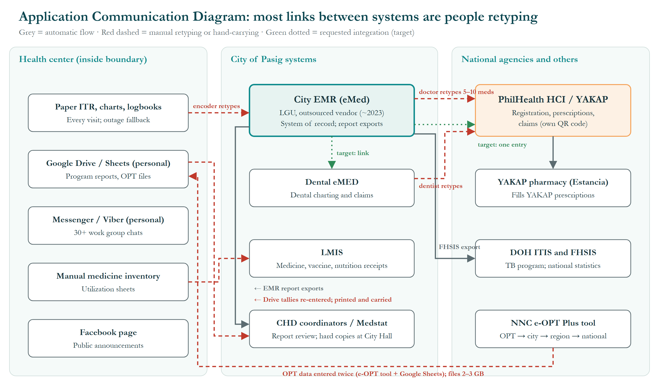
Figure 3. Application Communication Diagram.
How to read it: three zones: inside the health center (left), City of Pasig systems (middle), national agencies and others (right). Grey = automatic flow; red dashed = manual retyping or hand-carrying; green dotted = requested integration.
- Automatic today: EMR report exports (including to DOH FHSIS) and the PhilHealth QR code used by the YAKAP pharmacy.
- Manual today: encoder retypes paper charts into the EMR; doctor retypes 5–10 medicines into YAKAP; dentist retypes into PhilHealth; Drive tallies are re-entered, printed and carried to the CHD; OPT data is entered twice (e-OPT tool and Google Sheets; files of 2–3 GB).
- Center-side tools (Google Drive, Messenger and Viber with 30+ work chats) run on personal accounts.
- Requested (WP8): EMR → YAKAP single entry and a dental eMED link; both are City and vendor decisions.

Application Gap Analysis
ID | Gap | Candidate ABB | Controlled by
AG-1 | City EMR and PhilHealth YAKAP not linked (doctor retypes 5–10 medicines) | Prescription interoperability | City / vendor / PhilHealth
AG-2 | Dental eMED separate from EMR and PhilHealth | Dental record integration | City / vendor
AG-3 | No tool for daily medicine stock and reorder alerts | Medicine inventory management | Health center
AG-4 | No patient queuing tool (none in any Pasig health center) | Patient flow management | Health center (CHO approval)
AG-5 | No official collaboration workspace | Shared work storage and messaging | Barangay
AG-6 | Program tallies captured on paper and retyped | Single tally capture and report generation | Health center
AG-7 | No appointment booking for dental and follow-ups | Appointment scheduling | Health center / City

- Abbreviations
Abbreviations, acronyms and reference codes used in this document and its figures, in alphabetical order.
Abbreviation | Meaning
ABB | Architecture Building Block (ABB-1 to ABB-9 are reference numbers)
ADM | Architecture Development Method, the step-by-step method of the TOGAF Standard
AG-1 … | Application gap reference number (Phase C)
BHW | Barangay Health Worker
BNS | Barangay Nutrition Scholar
BP | Blood pressure
CHD | City Health Department (Pasig City)
CHO | City Health Officer
DG-1 … | Data gap reference number (Phase C)
DOH | Department of Health
DTR | Daily Time Record
e-OPT | Electronic Operation Timbang Plus tool of the National Nutrition Council
eMed / eMED | Name of the City's electronic medical record system; “dental eMED” is its separate dental system
EMR | Electronic Medical Record
FHSIS | Field Health Services Information System (DOH)
FP | Family planning
GAMOT | PhilHealth Guaranteed and Accessible Medications for Outpatient Treatment
GB | Gigabyte (a unit of file size)
HCI | Health Care Institution (PhilHealth portal for health facilities)
Hon. | Honorable (title of elected officials)
IF-1 … | Interface reference number
ITIS | Integrated Tuberculosis Information System (DOH)
ITR | Individual Treatment Record (the patient's registration form)
LGU | Local Government Unit
LMIS | Logistics Management Information System
LMP | Last menstrual period
M1 | FHSIS monthly report form
MR-SIA | Measles-Rubella Supplemental Immunization Activity
NCD | Non-communicable disease (e.g., hypertension, diabetes)
NIP | National Immunization Program
NNC | National Nutrition Council
O2 sat | Oxygen saturation
OPT / OPT Plus | Operation Timbang Plus: yearly weighing and measuring of children aged 0–59 months
PhilHealth | Philippine Health Insurance Corporation
PR | Pulse rate
QR | Quick Response (a scannable square barcode)
RR | Respiratory rate
TB | Tuberculosis
TOGAF | The Open Group Architecture Framework (the TOGAF® Standard)
UA&P | University of Asia and the Pacific
UPSC | Unique Prescription Security Code
WP1 … WP9 | Work package (a group of related changes delivered together)
YAKAP | PhilHealth Yaman ng Kalusugan Program (primary-care benefit)

